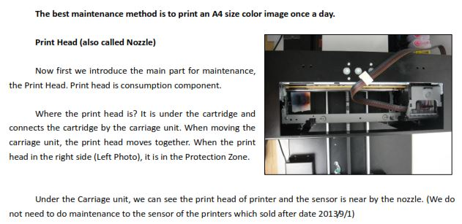
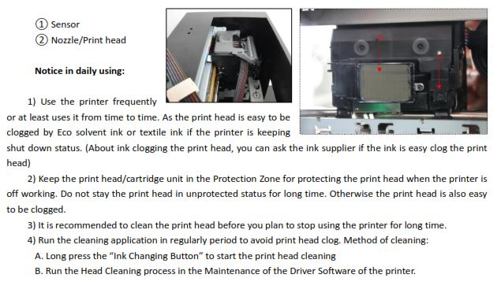
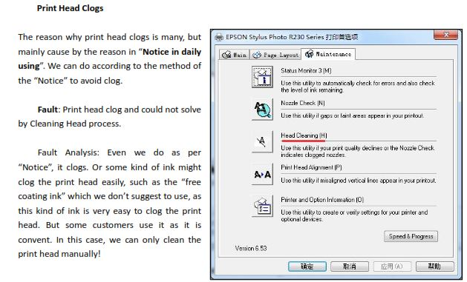
Clogs can occur when you mix ink from different batches in the cartridges. Also if the printer is not used daily, ink dries up and clogs. That’s why we advise do 1 print a day, either nozzle check or print 1 sheet daily.

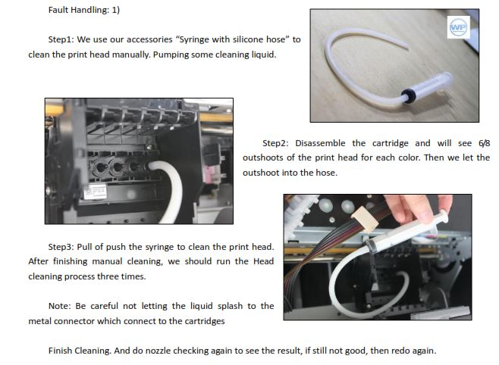
See video for maintenance cleaning of print head manually

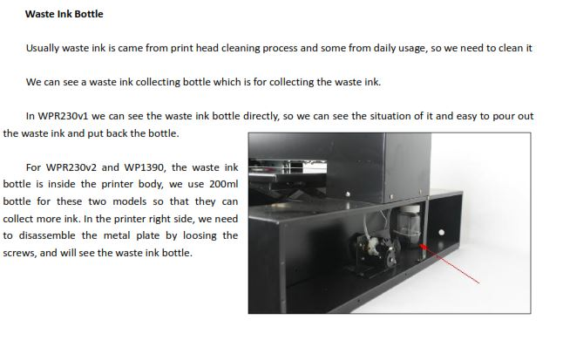Empty waste ink bottle when it is full.

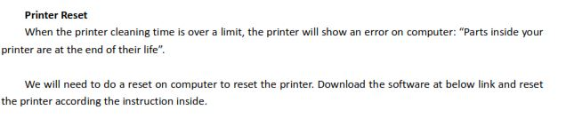
When you run daily cleaning on printer using software, the software maintains a count. Sometimes when you get to a certain count ,you may get error message above. There is nothing wrong with your printer. You have to just do the software reset on the computer. Download software reset at link provided. http://www.cake-stock.com/flatbed-printer-resources.html

File is .rar , get RAR file extractor(WINRAR) if you do not have it at CNET to open file

