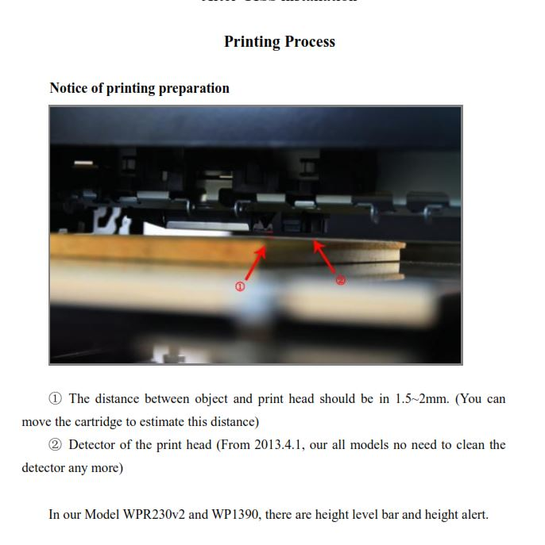
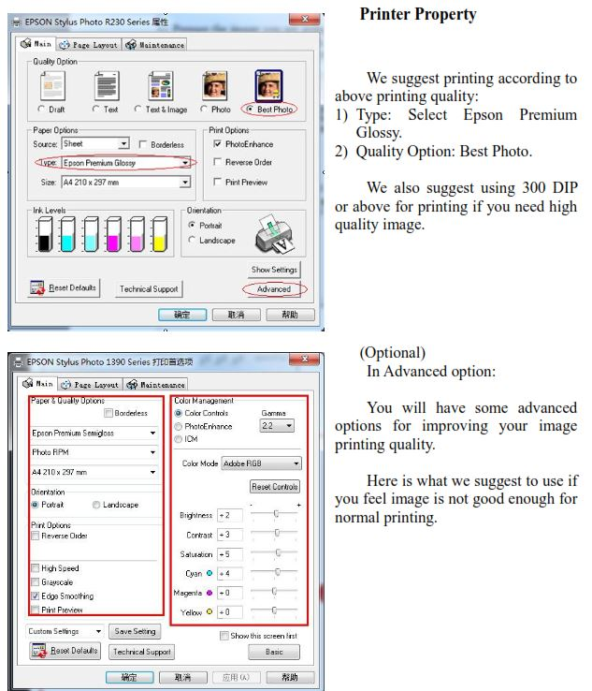

Printing process Example
You are printing on an object that has dimensions 60x115mm. Generally you add 1mm to each dimension measurement to get the full image printed on the object, so your printing range would be 61x116mm.
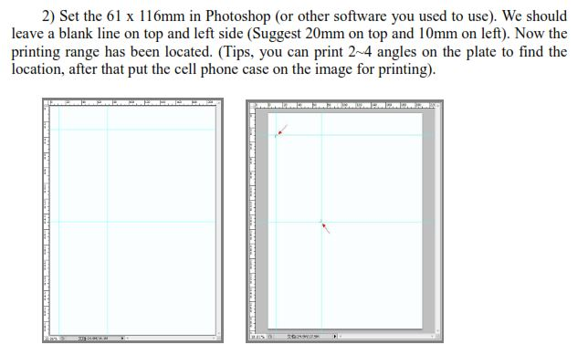

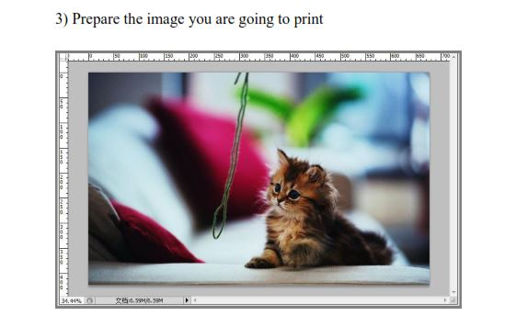

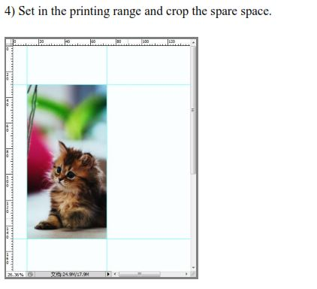

Move the platform tray to the starting position, all the way to the back (see video on printer operation)

Make sure object and print head do NOT COLLIDE.HEIGHT BAR prevents this ( see video on printer operation)

Print on your flat surface
